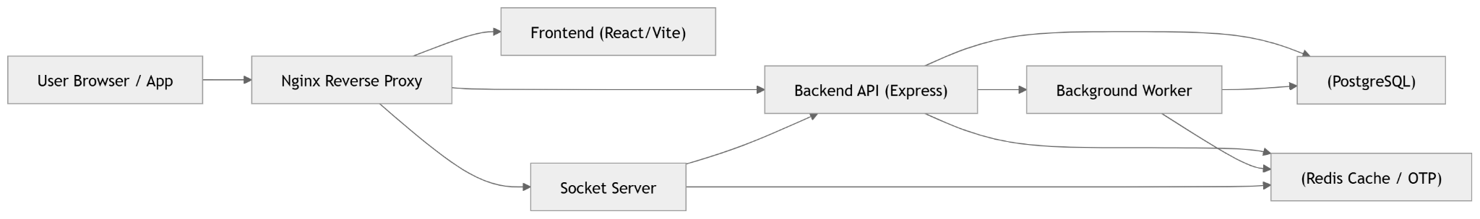COMPLETE SYSTEM ARCHITECTURE (FINAL)

AUTHENTICATION + ONBOARDING FLOW (FULL)
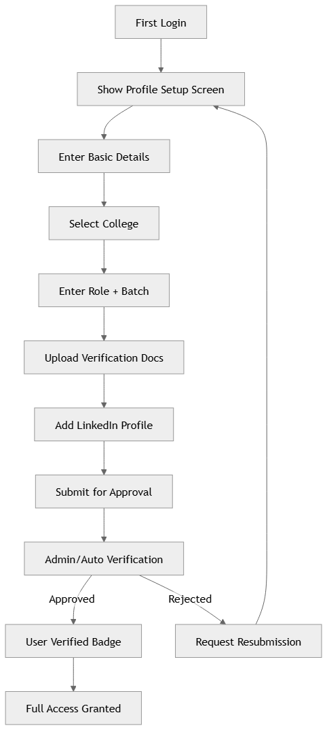
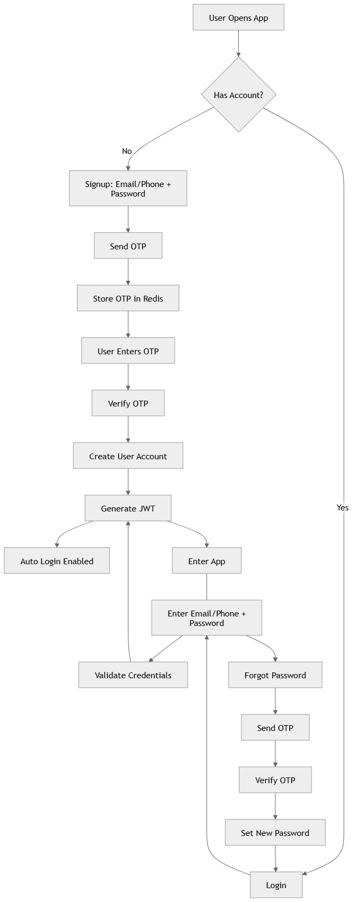
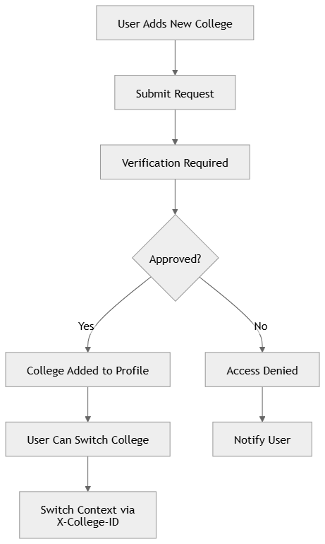
MULTI-COLLEGE ACCESS FLOW (STRICT CONTROL)
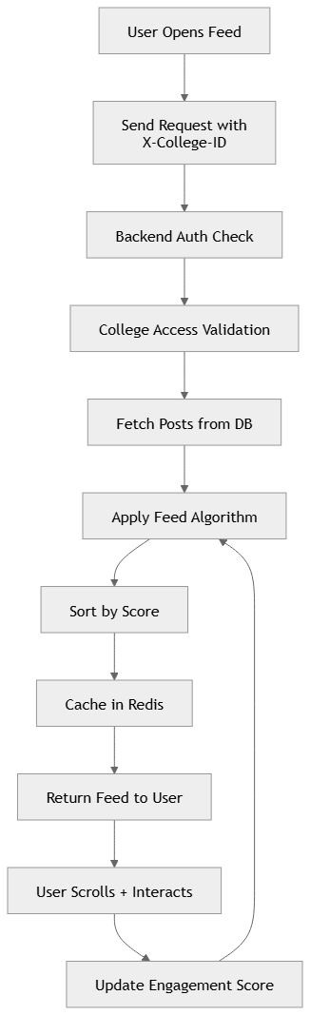
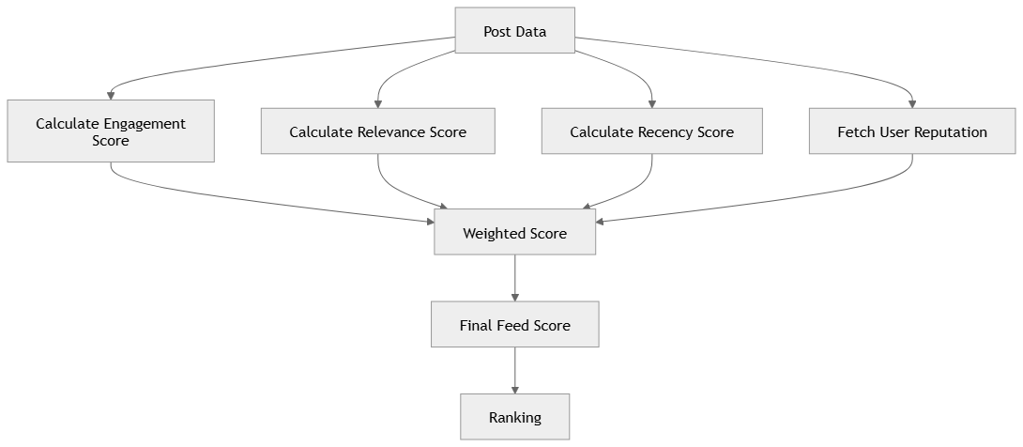
FEED ALGORITHM FLOW (INTERNAL)
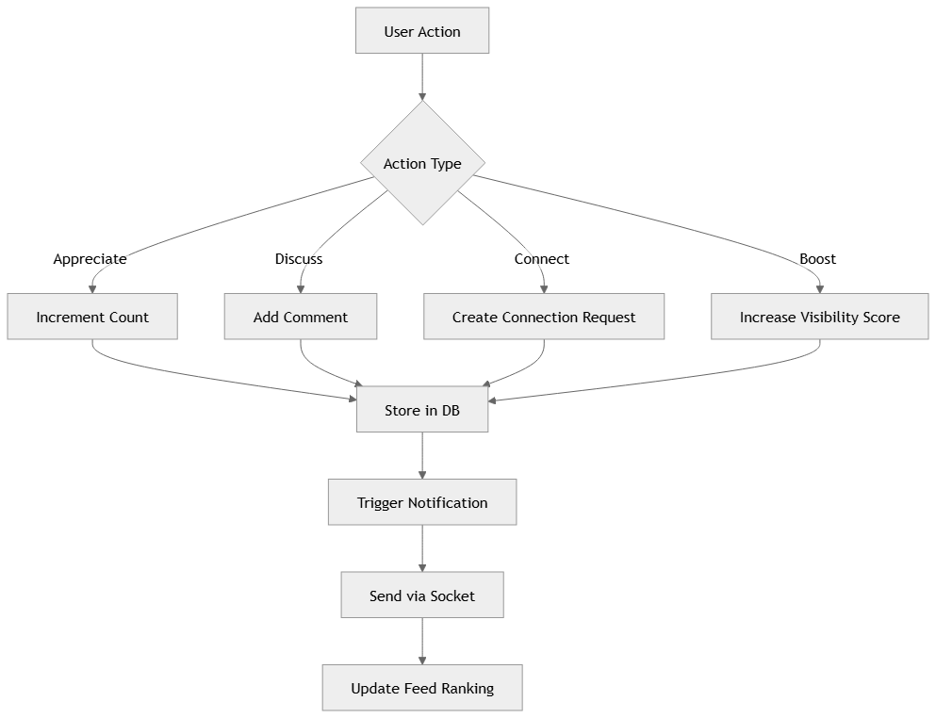
. INTERACTION FLOW (APPRECIATE / DISCUSS / CONNECT / BOOST)

